

|  |  |  |  |  |  |  |  |  |  |  |  |  |  |  |
| --- | --- | --- | --- | --- | --- | --- | --- | --- | --- | --- | --- | --- | --- | --- |
| COGNIZANT  Recommendation: Sell  Stock data as on 11th February 2025   |  |  | | --- | --- | | 52 week H/L (in USD): | 63.8-90.8 | | Market Cap(in USD): | 37.54 Billion | | Outstanding Shares(in USD): | 497.4 Million | | CMP: | 87.9 USD | | Target Price: | 75.77 USD | | Dividend Yield(in %): | 1.63% | | Ticker: | CTSH | |
|  |
| Valuation date: 11th February 2025  Cognizant Technology Corporation Solutions  Authored by: Nikhil Pandey |



# About The Company

|  |  |  |  |  |  |  |  |  |  |  |  |  |  |  |
| --- | --- | --- | --- | --- | --- | --- | --- | --- | --- | --- | --- | --- | --- | --- |
| |  |  | | --- | --- | | Cognizant is a global leader in technology services and consulting, headquartered in Teaneck, New Jersey. Founded in 1994, it specializes in digital transformation, IT services, and business process outsourcing. With a workforce exceeding 300,000 employees Worldwide, Cognizant serves industries like healthcare, finance, retail, and manufacturing. The company focuses on innovative solutions, leveraging artificial intelligence, cloud computing, and data analytics to drive client success. Known for its client-centric approach, Cognizant emphasizes sustainability and diversity in its operations. Listed on NASDAQ (CTSH), it reported revenues of over $19 billion in recent years, solidifying its position as a key player in the tech industry. | **Key Highlights**:  Cognizant has shown resilience and growth, key for investors. In 2024, Q4 revenue reached $5.1 billion, up 6.8% year-over-year, with full-year revenue at $19.7 billion, a 2% increase. The company delivered a 15.1% adjusted operating margin, exceeding guidance, and secured $26.3 billion in bookings, up 9% from 2023. Strong performance in Health Sciences and Financial Services, driven by AI innovations like Neuro and Flowsource, fueled six major deals in Q3 alone. With $2 billion in free cash flow (95% of net income), Cognizant continues to prioritize shareholder value through repurchases and dividends |     ***Source: Company Information*** Reported Business Segments Our **HS segment** consists of healthcare providers and payers, and life sciences companies, including pharmaceutical, biotech and medical device companies. Demand in this segment is driven by emerging industry trends, including the shift towards consumerism, outcome-based care, digital health and delivering seamless, patient-centered experiences.  Our **FS segment** includes banking, capital markets, payments and insurance companies. Demand in this segment is driven by our clients’ need to modernize legacy infrastructure and adopt digital technologies to serve their customers while complying with significant regulatory requirements and adapting to market changes.  Our **P&R segment** includes manufacturers, automakers, retailers, consumer goods companies, and travel and hospitality companies, as well as businesses providing logistics, energy and utility services. Demand in this segment is driven by our clients’ focus on improving the efficiency and sustainability of their operations; the enablement and integration of mobile platforms to support sales and customer experience enhancement initiatives; the generational shift from mechanical to software-defined, experience-driven vehicles; grid modernization to support a consumer-driven energy landscape that enables cleaner, more efficient energy use; and their adoption and integration of digital technologies, such as intelligent systems to manage supply chains and enhance overall customer experiences, and IoT to generate data and insights for factories, fleets, products and real estate companies.  Our **CMT segment** includes global communications, media and entertainment, education, information services and technology companies. Demand in this segment is driven by our clients’ need for services related to digital content, business process automation, AI adoption, operational efficiency, unified user experiences and the generation of new revenue streams. Risk factors  |  |  | | --- | --- | | Cybersecurity Risk | Potential material impact from cybersecurity breaches, including nation-state threat actors accessing systems, requiring accurate and updated disclosures in SEC filings. | | Foreign Corrupt Practices Act Violations | Risk of bribery and corruption, such as improper payments to foreign officials (e.g., India), leading to legal and financial penalties. | | Intellectual property protection | Inability to enforce or protect proprietary methodologies and IP, potentially harming competitiveness. | | Regulatory and tax risk in India | Exposure to Indian tax laws, including Minimum Alternative Tax (MAT) and potential changes affecting deferred tax assets, impacting financial condition. | | Competition and Market position | Intense competition from larger or local firms with greater resources, affecting market share and profitability. | | Internal Controls and Disclosure Obligations | Risk of violating SEC internal accounting and disclosure controls, even without financial misstatement, due to expanded SEC scrutiny. | |
| *“I am deeply grateful to our employees for their commitment to our strategic priorities and rigorous execution, which drove fourth quarter revenue growth to the high end of our guidance range. We exited the year with momentum — closing a record 29 large deals during the year — highlighting the effectiveness of our strategy.*  *In 2024, we accelerated investments in our AI-led platforms and added new capabilities with the acquisitions of Thirdera and Belcan, further strengthening and diversifying our portfolio.”-* *Ravi Kumar S, Chief Executive Officer* |
| ***Company Snapshot***   ***Source: Company Information*** **Peer Group Review**   ***Source: Company Information***  *Cognizant is a notable player in the technology and consulting sector, as depicted in the provided data. With a revenue of $19 billion, it ranks at the 74th percentile, indicating strong performance relative to peers. Its market capitalization stands at $35 billion, placing it at the 43rd percentile, suggesting a moderate valuation compared to competitors like Accenture ($194 billion) and Adobe ($192 billion). Cognizant's headcount of 341,000 employees is impressive, ranking at the 95th percentile, reflecting a large workforce that likely supports its extensive service offerings. This combination of revenue, market cap, and headcount highlights Cognizant's significant industry presence*. Key Statistics  |  |  |  |  | | --- | --- | --- | --- | | Previous Close | $75.90 | Net Income | $2.24 Billion | | Sector | Technology | EPS | $4.42 | | Day’s range | $75.37 - $77.93 | Dividend Yield | 1.50% | | 52 week Range | $63.79 - $90.82 | Gross profit margin | 34.37% | | Market Cap | $39.51 billion | P/E ratio | 17.63 | | Shares outstanding | 495.7 Million | Return on assets | 9.78% | | Revenue | $19.41 Billion | Return on Equity | 16.48% | | Net income | $2.24 Billion | EBITDA | $3.43 Billion |       ***Source: Company Information***  *The chart compares five-year cumulative total returns for Cognizant Technology Solutions, the S&P 500 Index, and the S&P 500 Information Technology Index from 12/31/19 to 12/31/24. Cognizant’s return peaked at $146.84 in 2021 but fell to $133.62 by 2024, underperforming both indices, which reached $197.59 and $299.72, respectively.* |

Historical EBIT,EBITDA and Revenue from 2020-2024

DSO and DPO

|  |  |
| --- | --- |
|  |  |

*Cognizant's DSO has increased from 68 to 75 over five periods, indicating slower receivables collection. DPO decreased from 13 to 10, suggesting faster payables turnover. This reflects potential cash flow challenges, requiring improved credit management to optimize working capital efficiency.* *In 2022, Cognizant’s revenue grew ~5%, but EBIT stagnated due to rising costs and operational inefficiencies. 2023 saw margin pressure from high attrition and execution issues, causing EBIT to drop. 2024* shows early recovery with revenue and EBIT improving slightly, but performance remains below 2022 peak levels.

Software and IT Services sector overview

## Macroeconomic Trends for U.S.A

These macroeconomic trends have significant implications for U.S. companies and the global market:​

* Inflationary Pressures: Elevated inflation can erode consumer purchasing power and increase input costs for businesses, potentially squeezing profit margins.​
* Monetary Policy Adjustments: The Federal Reserve's interest rate reductions aim to stimulate economic activity. However, lower rates can compress net interest margins for financial institutions.​
* Economic Growth Moderation: A deceleration in GDP growth may signal reduced demand, prompting companies to reassess expansion plans and potentially impacting earnings forecasts.​
* Labour Market Stability: A steady unemployment rate suggests a balanced labour market, which can support consumer spending but may also indicate limited room for employment growth.​
* Consumer Behaviour: Strong consumer spending bolsters revenue for companies reliant on domestic demand, while a decline in business investment could signal caution and affect sectors tied to capital expenditures.

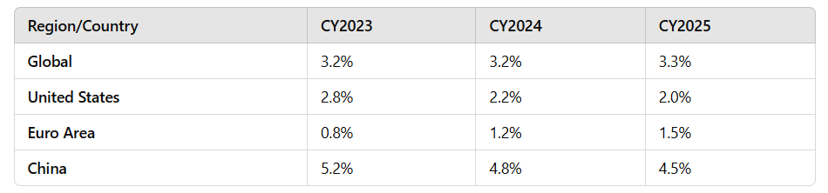

Sector Analysis

The software and IT services sector is a dynamic and rapidly evolving industry, driven by constant technological advancements and the increasing reliance of businesses and individuals on digital solutions. Here's an overview of key aspects of this sector:

**Key Trends and Drivers**

Digital Transformation: Businesses across all sectors are undergoing digital transformation, which involves integrating digital technology into all areas of their operations. This is a major driver of growth in the software and IT services sector.

Cloud Computing: The adoption of cloud-based solutions (SaaS, PaaS, IaaS) continues to accelerate, offering businesses increased flexibility, scalability, and cost-effectiveness.

Artificial Intelligence (AI) and Machine Learning (ML): AI and ML are transforming various industries, with applications in areas such as automation, data analytics, and customer service.

Cybersecurity: With the increasing prevalence of cyber threats, cybersecurity has become a critical concern for businesses and individuals. This is driving demand for cybersecurity software and services.

Data Analytics: The ability to collect, analyse, and interpret data is essential for businesses to make informed decisions. This is driving demand for data analytics software and services.

Mobile Technologies: The widespread use of mobile devices has created a demand for mobile applications and services.

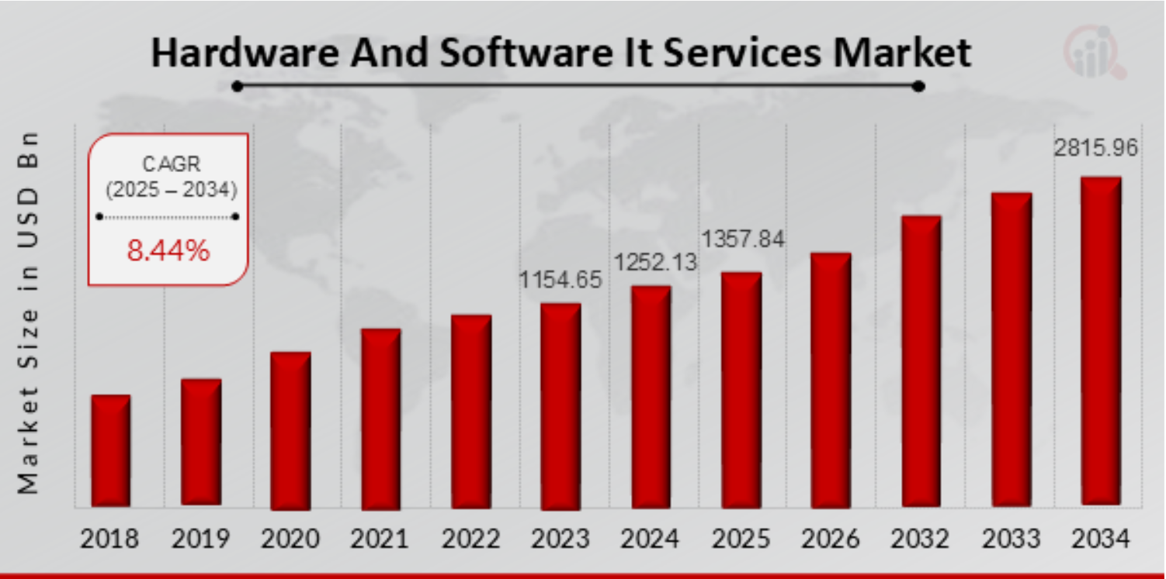

***Source: Company Information***

Market Growth and Trends:

* Steady Growth:
  + The U.S. IT services market is projected to experience steady growth in the coming years.
  + Factors such as increasing IT spending and technological advancements are driving this growth.
* Focus on Proactive Services:
  + There's a growing trend towards proactive IT services, where providers anticipate and prevent issues before they occur.
* Key Growth Drivers:
  + Cloud services, cybersecurity, and data analytics are among the key growth drivers.
  + AI and automation are also playing an increasingly important role.

Market growth and trends in USA

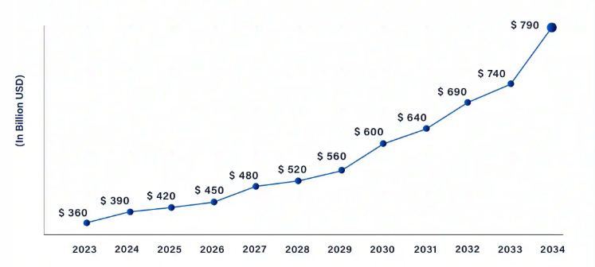

***Source: Company Information***

Factors Influencing the Market:

* Economic Conditions:
  + Economic fluctuations can impact IT spending, but digital transformation is now considered essential.
* Technological Advancements:
  + Rapid technological advancements create new markets and opportunities.
* Regulatory Environment:
  + Data privacy and security regulations influence how businesses handle data and use IT services.

Market Share by region

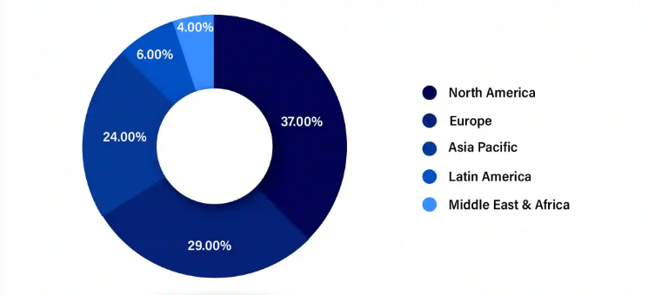

*Source: Company Information*

ESG Analysis

Cognizant Technology Solutions demonstrates a structured approach to Environmental, Social, and Governance (ESG) initiatives, emphasizing sustainability, social responsibility, and robust governance.​

Environmental Initiatives: Cognizant has committed to achieving net-zero greenhouse gas emissions by 2040. The company is investing in renewable energy sources and collaborating with suppliers to reduce environmental impact. In 2022, Cognizant set public, measurable goals for reducing greenhouse gas emissions, reflecting significant progress in its environmental strategy. ​

Social Responsibility: Cognizant focuses on workforce development and diversity. Since 2018, it has invested $70 million in philanthropic efforts supporting 77 organizations dedicated to workforce preparation. The Synapse skilling initiative, launched in 2023, aims to train one million individuals in generative AI and other advanced technologies by the end of 2026. Additionally, the Shakti program seeks to enhance women's representation and leadership within the company, resulting in women comprising over 41% of new hires and an increase in senior female leadership from 11.1% in 2022 to 19.4% globally.

Governance Practices: Cognizant integrates ESG oversight and transparency into its governance framework, focusing on supply chain management, health and safety, ethics, data privacy, and security. The company has added environmental requirements to its Supplier Standards and launched a Supplier Diversity Program in the US. These measures underscore Cognizant's commitment to ethical operations and responsible corporate citizenship.

Overall, Cognizant's ESG initiatives reflect a comprehensive strategy aimed at fostering environmental sustainability, social equity, and strong governance practices.​

Porter’s Five Forces Analysis for Cognizant with Market Comparison

|  |  |  |
| --- | --- | --- |
| **Force** | **Cognizant Analysis** | **Market Comparison** |
| Threat of New Entrants | **Low** – High entry barriers due to brand reputation, client relationships, and economies of scale. However, niche players (e.g., EPAM, Globant) can enter with specialized services. | **Accenture, TCS, and Infosys** face similar barriers but also benefit from even stronger brand recognition and client stickiness, making entry even tougher**.** |
| Bargaining Power of Suppliers | **Moderate** – IT professionals are the key suppliers. High attrition in the industry gives employees leverage, but Cognizant’s global presence diversifies labor risks. | **TCS and Infosys** have lower attrition due to strong internal training programs, reducing supplier power. **Accenture** faces similar labor costs but has strong employer branding. |
| Bargaining Power of Buyers | **High** – Large enterprises have multiple IT vendors to choose from, creating pricing pressure. Clients demand cost-effective, high-quality solutions. | **TCS and Infosys** compete on cost efficiency, while **Accenture** competes on premium consulting services, reducing direct price competition. |
| Threat of Substitutes | **Moderate** – Automation, AI, and in-house IT teams can replace outsourced services. However, Cognizant’s expertise in digital transformation mitigates this risk | **Accenture’s AI-driven automation tools** and **TCS’s platform** are strong substitutes, increasing competition. **Infosys also invests heavily in AI-driven IT solutions.** |
| Industry Rivalry | **High** – Strong competition from Accenture, TCS, Infosys, Wipro, and Capgemini creates price and innovation pressure. | Accenture leads in high-end consulting, TCS in cost-effective IT solutions, Infosys in automation, and Wipro in cloud services. Cognizant needs to differentiate through domain expertise and digital transformation. |

## BCG Matrix

|  |  |  |
| --- | --- | --- |
| Category | Business Segment | Analysis |
| ****Stars**** ⭐ | Digital Services (AI, Cloud, IoT, Cybersecurity, Data Analytics) | High growth and high market share. Digital transformation is a key revenue driver for Cognizant, competing with Accenture and TCS in AI, cloud, and analytics. Investments in these areas are crucial for future growth. |
| ****Cash Cows**** 💰 | Financial Services & Healthcare IT Solutions | High market share but slow growth. These are Cognizant’s largest revenue segments, generating stable cash flow. Despite slow industry growth, demand for IT services in BFSI and healthcare remains strong. |
| ****Question Marks**** ❓ | Products & Resources, Media & Communications | High growth but low market share. Cognizant is expanding in manufacturing, retail, and telecom IT services, but faces competition from SAP, Oracle, and niche players. Requires investment to increase market penetration. |
| ****Dogs**** 🐶 | Legacy IT & Maintenance Services | Low growth and low market share. Traditional IT outsourcing and maintenance services are declining due to automation and cloud adoption. Cognizant should gradually shift focus to high-growth digital services. |

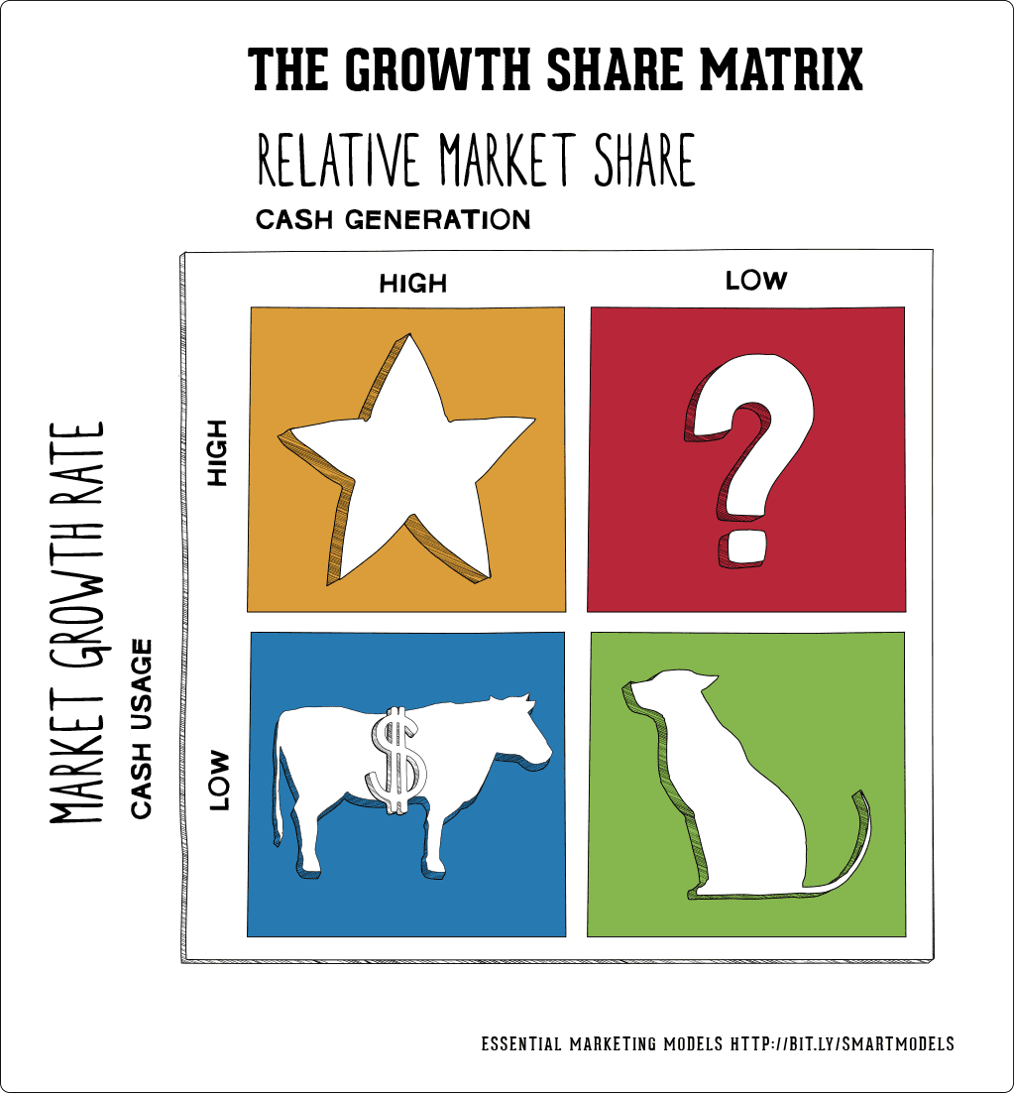

SWOT Analysis

Shareholding Pattern

Cognizant Technology Solutions Corporation's shareholding pattern is as follows:​

Institutional Investors: Approximately 67.29% to 97.6% of shares are held by institutional entities. ​

* Individual Insiders: Holdings range from 0.16% to 0.173%.
* General Public/Retail Investors: Ownership varies between 2.11% and 32.55%. ​

Top Institutional Shareholders:

1. The Vanguard Group, Inc.: Approximately 11.7% to 11.93% ownership. ​
2. BlackRock, Inc.: Holds about 10.67% to 11.26% of shares. ​
3. State Street Corporation: Owns roughly 5.03% to 5.04% of shares.
4. Pzena Investment Management, Inc.: Approximately 3.57% to 3.75% ownership. ​
5. Dodge & Cox: Holds about 3.7% to 3.71% of shares.

## Managerial Team of Cognizant

|  |  |  |
| --- | --- | --- |
|  | Zein Abdalla  Director Since 2015  Age 65  Independent | Mr. Abdalla brings to Cognizant’s Board of Directors decades of experience having led and shaped large‑scale operations across the world as President and a manager of key divisions of PepsiCo. |
|  | Vinita Bali  Director Since 2020  Age 68  Independent | Ms. Bali brings experience to the Cognizant Board of Directors gained through leading large multinationals in CEO and senior marketing and sales roles around the globe, having worked for over three decades with companies like Britannia Industries, The Coca‑Cola Company and Cadbury Schweppes plc. |
|  | Eric Branderiz  Director Since 2023  Age 59 Independent | Mr. Branderiz brings to Cognizant’s Board of Directors experience in finance, accounting, M&A execution, risk management, ESG and corporate governance across various energy, semiconductor and technology sectors, including Enphase Energy and Tesla |
|  | Archana Deskus  Director Since 2020  Age 58  Independent | Ms. Deskus brings CTO and CIO experience to Cognizant’s Board of Directors, setting and leading the technology strategy for large global corporations, including PayPal, Intel, Hewlett Packard, Baker Hughes, Ingersoll Rand, Timex and North America HVAC. Period Relevant experience Key q |
|  | John M. Dineen  Director Since 2017  Age 61  Independent | Mr. Dineen brings to Cognizant’s Board of Directors experience from having managed several key business divisions of General Electric and in the healthcare industry from having served as President and CEO of GE Healthcare |
|  | Ravi Kumar S  CEO of Cognizant Director  Since 2023  Age 52 | Ravi Kumar Singisetti (also referred to as Ravi Kumar S or Ravi Kumar) was appointed Chief Executive Officer of Cognizant in January 2023. In his role as CEO, Mr. Kumar sets the strategic direction of the company, promotes Cognizant’s client‑first culture, and focuses on ensuring sustainable growth and driving long‑term shareholder value |
|  | Leo S. Mackay  Director Since 2012 Age 62  Independent | Dr. Mackay brings expertise in auditing and compliance, security, government contracting, and federal government senior policymaking to Cognizant’s Board of Directors through his positions at Lockheed Martin and in the Bush administration |
|  | Michael Patsalos  Director Since  2012  Age 71  Independent | Mr. Patsalos‑Fox brings decades of experience counseling clients in the technology and consulting space to Cognizant’s Board of Directors, gained from his 32‑year tenure in senior roles with McKinsey & Company and his role as CEO for Vidyo, as well as expertise in the cybersecurity space from his experience as CEO of Stroz Friedberg. |
|  | Stephen "Steve" J. Rohleder  Director Since 2022  Age 66  Independent | Mr. Rohleder brings decades of experience overseeing operations, developing strategy, counseling clients and developing teams in the technology space to Cognizant’s Board of Directors, gained from his 35‑year tenure in senior roles with Accenture and his roles as a board member and later CEO of GTY Technology Holdings |
|  | Abraham “Bram” Schot  Director Since 2023  Age 62  Independent | Mr. Schot brings international strategic, leadership and transformational expertise to Cognizant’s Board of Directors from more than three decades of experience in the automotive industry, including management positions at DaimlerChrysler, Mercedes‑Benz, Volkswagen Group and Audi. |
|  | Joseph M. Velli  Director Since 2017  Age 66  Independent | Mr. Velli brings experience to Cognizant’s Board of Directors in creating, building and leading global large‑scale technology, processing and software platform businesses as a Senior EVP for The Bank of New York and as CEO of ConvergEx Group. |
|  | Sandra S. Wijnberg Former CFO of Marsh & McLennan Companies  Director Since 2019 Age 67  Independent | Ms. Wijnberg brings to Cognizant’s Board of Directors expertise in managing a large global professional services business from her role as CFO of Marsh & McLennan Companies, as well as a private equity perspective from her position as Partner and CAO of Aquiline Holdings. |

## CEO Pay ratio

|  |  |  |  |
| --- | --- | --- | --- |
| Category | Median Employee Annual Total compensation | CEO annual Total Compensation | Pay Ratio(CEO:Median Employee) |
| CEO Pay to Worldwide Median Employee Pay (SEC‑required pay ratio disclosure | *$40,660* |  | *556 : 1* |
| CEO Pay to U.S. Median Employee Pay (Supplemental pay ratio information) | *$125,791* | *$22,617,945* | *180 : 1* |

*The data shows a significant pay disparity between the CEO and median employees. The CEO earns $22,617,945 annually, while the worldwide median employee earns $40,660 (556:1 ratio) and the U.S. median employee earns $125,791 (180:1 ratio). This highlights a stark compensation gap, especially globally.*

# ****Cognizant Equity Research Report****

**Valuation Date: 11-02-2025**

## **Investment Summary**

Cognizant exhibits stable revenue growth driven by Healthcare, Products & Resources, and Communication, Media & Technology segments, while Financial Services faces challenges. The company maintains strong cash flow generation, disciplined capital expenditures, and strategic shareholder returns. However, the DCF valuation estimates an intrinsic share price of ****$70.45****, which is ****below the current market price****, indicating overvaluation.

## **Financial & Valuation Highlights**

### ****Revenue & Profitability Outlook****

1. **Total revenue** expected to reach **$24.76B by 2029**, supported by diversified sectoral exposure.
2. **Healthcare** remains the most stable segment, growing at **5% YoY from 2025 onward**.
3. **Products & Resources and Communication, Media & Technology** to grow at **7% CAGR**.
4. **Financial Services** segment needs strategic revival due to near-term volatility.
5. **EBIT** projected to grow from **$2.99B in 2025 to $3.68B by 2029** (**CAGR: 5.3%**).
6. **Net Operating Profit After Tax (NOPAT)** expected to reach **$2.91B in 2029**, reflecting operational efficiency gains.

### ****Cash Flow & Capital Allocation****

1. **Free Cash Flow to the Firm (FCFF)** projected at **~$2.96B in 2029**, maintaining financial flexibility.
2. **Capital expenditures (CAPEX)** remain stable, averaging **~$600M per year**, ensuring reinvestment without overextension.
3. **Disciplined cost management** and **rising share buybacks (~58% of net income post-2025)** enhance shareholder value.
4. **Strong cash generation** ensures robust liquidity, with **cash reserves projected to reach $4.54B by 2029**.

### ****Balance Sheet & Financial Stability****

1. **Total assets** projected to reach **$22.54B by 2029**, driven by consistent earnings retention.
2. **Debt levels** are well-managed, with long-term liabilities gradually declining.
3. **Goodwill and intangibles** remain stable, indicating a steady acquisition strategy.
4. **Strong liquidity** and **controlled leverage** reinforce balance sheet strength.

### ****Asset Turnover & Operational Efficiency****

1. **Accounts Receivable Turnover Ratio (ARTR)** improving from **5.39 (2020) to 4.86 (2024)**, indicating efficiency gains.
2. **Days Sales Outstanding (DSO)** rising from **67.66 (2020) to 75.07 (2024)**, suggesting longer collection periods.
3. **Accounts Payable Turnover Ratio (APTR)** stabilizing at **38 (2024)**, reflecting supplier payment consistency.
4. **Days Payable Outstanding (DPO)** consistent at **~11 days**, ensuring steady supplier management.
5. **PPE Turnover Ratio** improving from **10 (2020) to 14 (2024)**, indicating effective asset utilization.

## **Valuation Analysis**

### ****Discounted Cash Flow (DCF) Valuation****

**WACC**: **8.48%** | **Long-Term Growth Rate (LTGR)**: **2.60%**  
**Intrinsic Share Price (DCF):** **$77.75**  
**Total Enterprise Value (EV):** **$35.03B**  
**Present Value of Terminal Value (Gordon Growth Model):** **$25.02B**

## **Investment Considerations & Risks**

### ****Upside Catalysts****

1. ****Healthcare & Emerging Segments Drive Growth**** – Stable expansion in Healthcare, Products & Resources, and CMT provides long-term revenue visibility.
2. ****Operational Efficiencies & Cost Control**** – Improved SG&A efficiency ($600M annually) enhance margins.
3. ****Strong Shareholder Returns**** – Significant buybacks (~58% of net income) and steady dividend payout (~28% of PAT) support investor confidence.

### ****Key Risks****

****Financial Services Weakness**** – Growth challenges in Financial Services pose revenue headwinds.

****Rising Cost Pressures**** – Higher cost of revenue may squeeze margins, requiring continued efficiency measures.  
****Macroeconomic Sensitivity**** – Global economic fluctuations and IT spending trends impact client demand and contract renewals.

## **Final Recommendation**

Cognizant’s **strong cash flows**, **diversified sector exposure**, and **disciplined capital allocation** ensure financial resilience. However, **weakness in Financial Services**, **rising cost pressures**, and **overvaluation based on DCF** indicate limited upside potential. Given that the DCF valuation suggests a fair value of ****$70.45****, which is **below the current market price**, the stock appears ****overvalued****.

🔹 **Investment Stance: SELL**  
🔹 **Target Price Range: $65 - $75**

Exhibit 1- Revenue Segment

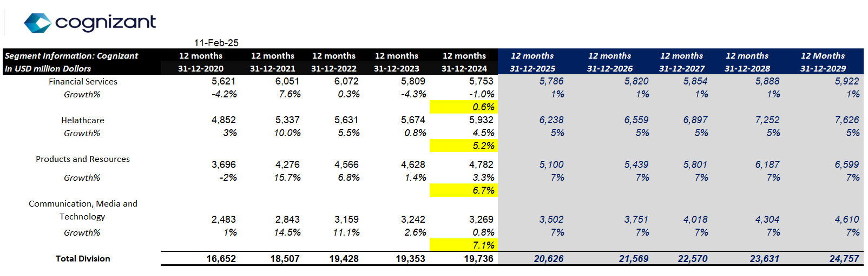

Exhibit2- Income Statement

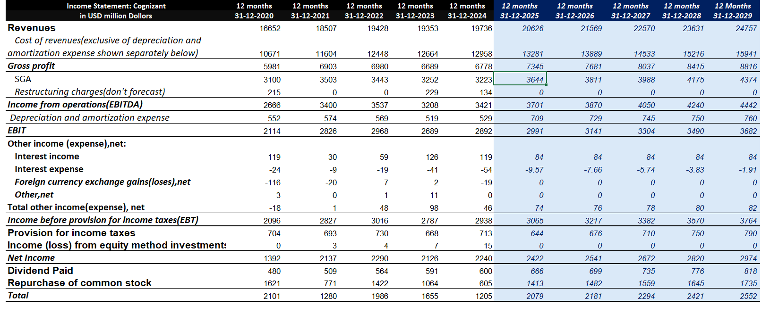

Exhibit 3- Balance Sheet

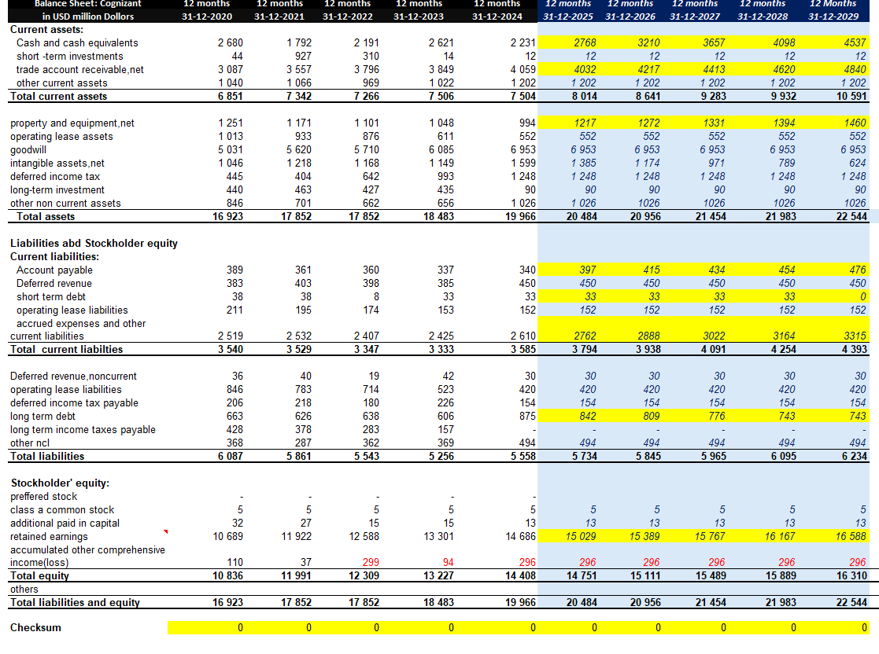

Exhibit 4- Cash Flow Statement

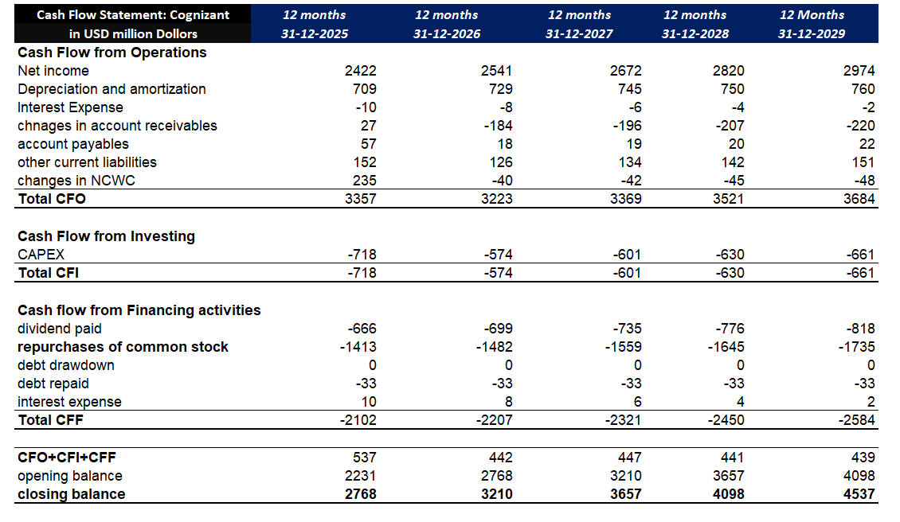

Exhibit – WACC Calculation

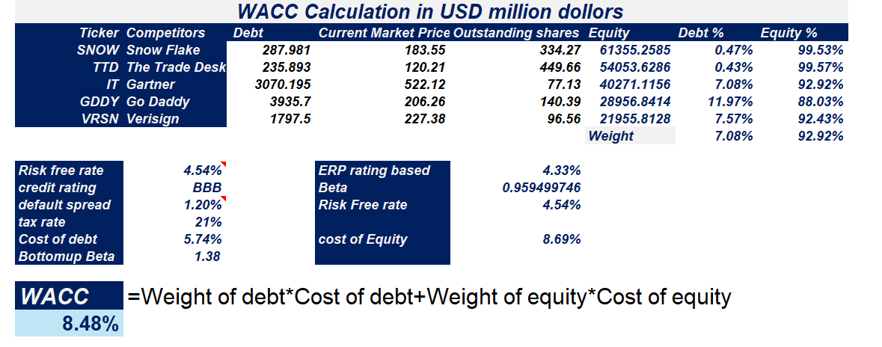

Exhibit 6- Beta Calculation

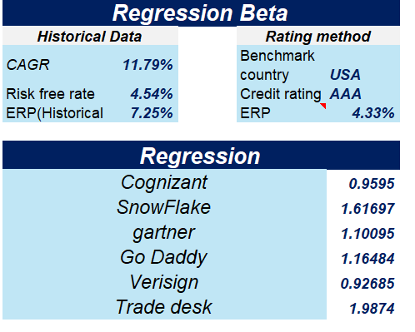

Exhibit 7- Bottom Up Beta

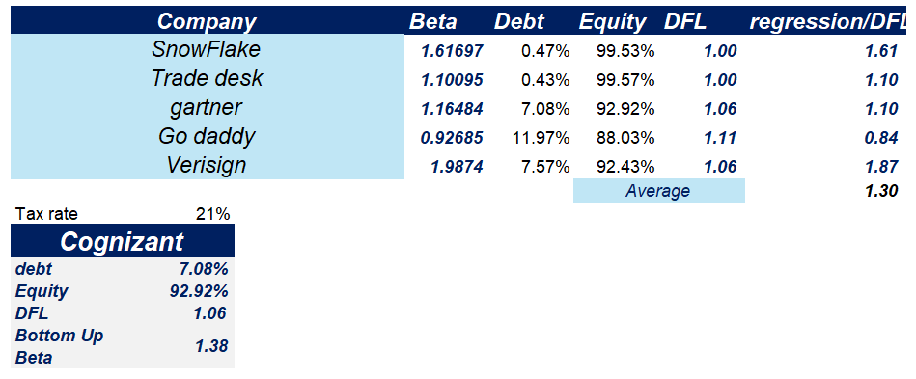

Exhibit 8- DCF Valuation

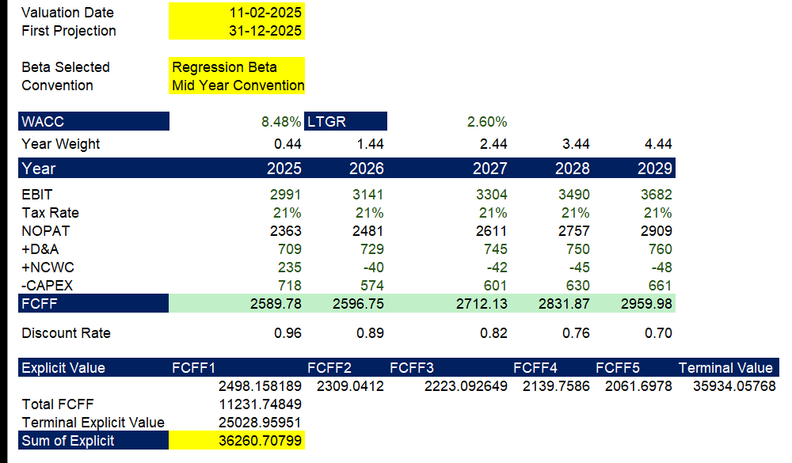

Exhibit 9- Sensitivity Analysis

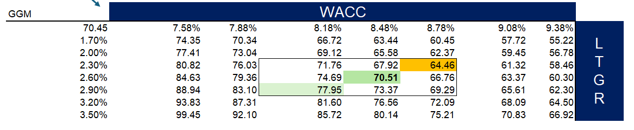

Sensitivity Analysis

### ****Sensitivity Analysis Summary – Cognizant DCF Valuation****

* **Base Case:** $70.51 (WACC = 8.48%, GGM = 2.60%).
* **WACC Impact:** Higher WACC lowers valuation (e.g., at 9.38%, price drops to $60.30); lower WACC increases it (at 7.58%, price rises to $84.63).
* **Growth Impact:** Higher terminal growth boosts valuation (3.50% → $80.14), lower growth reduces it (1.70% → $63.44).
* **Range:** Worst case ($55.22), best case ($99.45).
* **Conclusion:** DCF < market price → **SELL** stance..

# Du-Pont Analysis

Exhibit-10 Du Pont Analysis

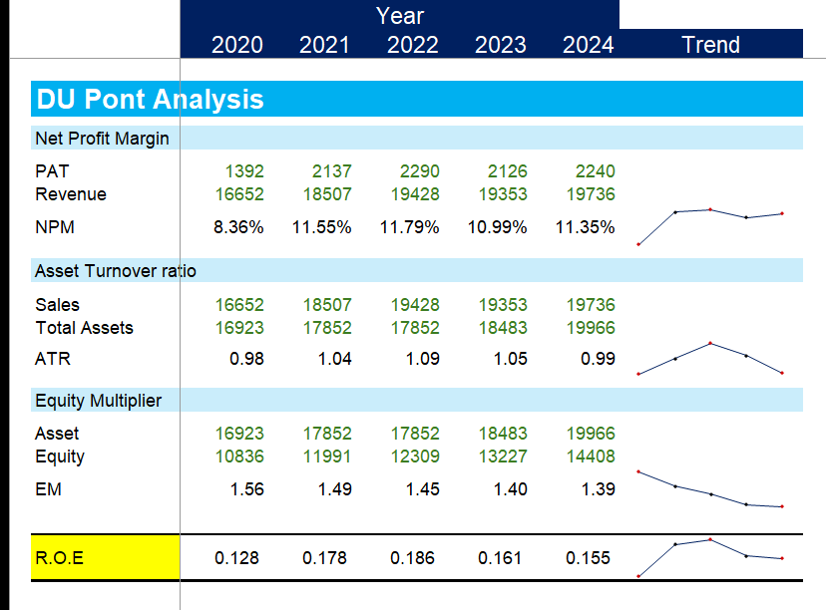

*Cognizant’s DuPont Analysis reflects stable profitability with Net Profit Margin improving from 8.36% in 2020 to 11.35% in 2024. Asset Turnover Ratio peaked in 2022 at 1.09 but moderated to 0.99 in 2024, indicating reduced asset efficiency. The Equity Multiplier consistently declined, reflecting stronger equity positioning and lower financial leverage. Consequently, Return on Equity (ROE) improved till 2022 but declined to 15.5% in 2024, driven by lower asset utilization and reduced leverage, despite stable margins.*

*The company demonstrates consistent profitability, with net profit margins stabilizing around 11–12%. Asset efficiency (ROA) peaked in 2022, driven by strong sales growth relative to assets, but has since moderated. The reduction in financial leverage indicates a shift toward a less risky capital structure, potentially lowering financial risk but also reducing the leverage-driven boost to ROE. Overall, ROE improved significantly from 2020 to 2022 but stabilized at 17% by 2024, suggesting a mature, stable performance with room for strategic optimization.*

# Ratio Analysis

# Exhibit 11- ratio Analysis

# 

• *Liquidity Position*: Current Ratio improved from 1.94 in 2020 to 2.25 in 2023, showing strong short-term solvency, but marginally dropped to 2.09 in 2024.

• *Working Capital Efficiency*:

* AR Turnover declined steadily from 5.39 to 4.86 → Slower receivable collections.
* AP Turnover improved from 27.43 to 38.11 → Efficient payment cycles.

• *Asset Efficiency*: Asset Turnover Ratio improved till 2022 (1.088) but slowed to 0.988 in 2024 → Lower asset utilization.

• *Leverage*: Debt-to-Equity reduced from 0.56 in 2020 to 0.39 in 2024 → Stronger capital structure, reduced reliance on debt.

• *Profitability*:

* ROCE peaked at 20.46% in 2022, fell to 17.65% in 2024 → Decline in operational efficiency.
* Interest Coverage Ratio fell from 88x to 54x → Still very comfortable but showing slight stress.

# Relative Valuation

* **Current Market Price (CMP):** $84.1 as of 11 February 2025.
* **Implied Per Share Valuation:** Ranges between **$120.56 and $338.4**, suggesting upside potential.
* **Valuation Multiples Used:**
  + **EV/EBITDA** (Enterprise Value to EBITDA)
  + **EV/EBIT** (Enterprise Value to EBIT)
  + **EV/Sales** (Enterprise Value to Sales)
  + **P/E Ratio** (Price to Earnings)
  + **Exit Multiple Method** (Terminal Value Calculation)
* **Key Valuation Insights:**
  + **EV/Sales multiple suggests the highest upside**, with a per-share range of **$277.3 to $338.4**.
  + **EV/EBITDA valuation range:** $182.8 - $222.9 per share.
  + **EV/EBIT valuation range:** $166.1 - $202.5 per share.
  + **P/E valuation range:** $124.1 - $151.6 per share.
  + **Exit Multiple Share Value:** $120.56 per share, based on an **EV/EBIT multiple of 24.8x** and a **terminal value of $71,721.6 million**.
* **Diluted Shares Outstanding:** 497.4 million, used for equity value calculation.
* **Investment Outlook:**
  + Cognizant appears **undervalued relative to industry peers**.
  + **Revenue and earnings growth projections remain strong**.
  + **Stock is positioned for potential appreciation**, based on current multiples, terminal value analysis, and market trends.

Exhibit 11- Trading Comps Valuation

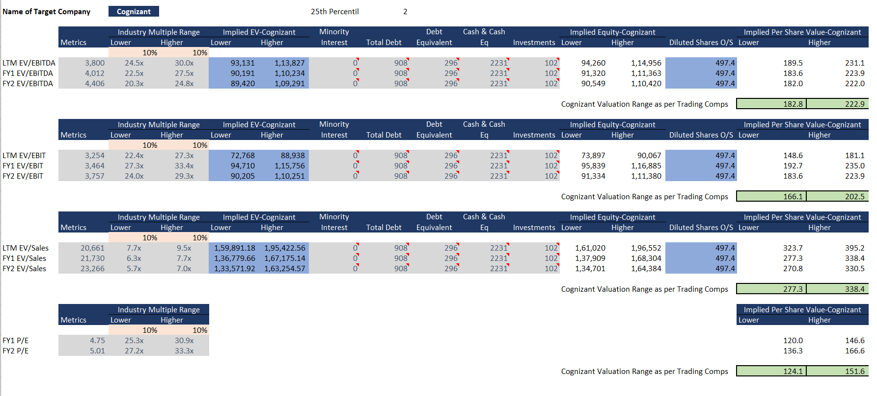

Exhibit 12- Trading Comps Output

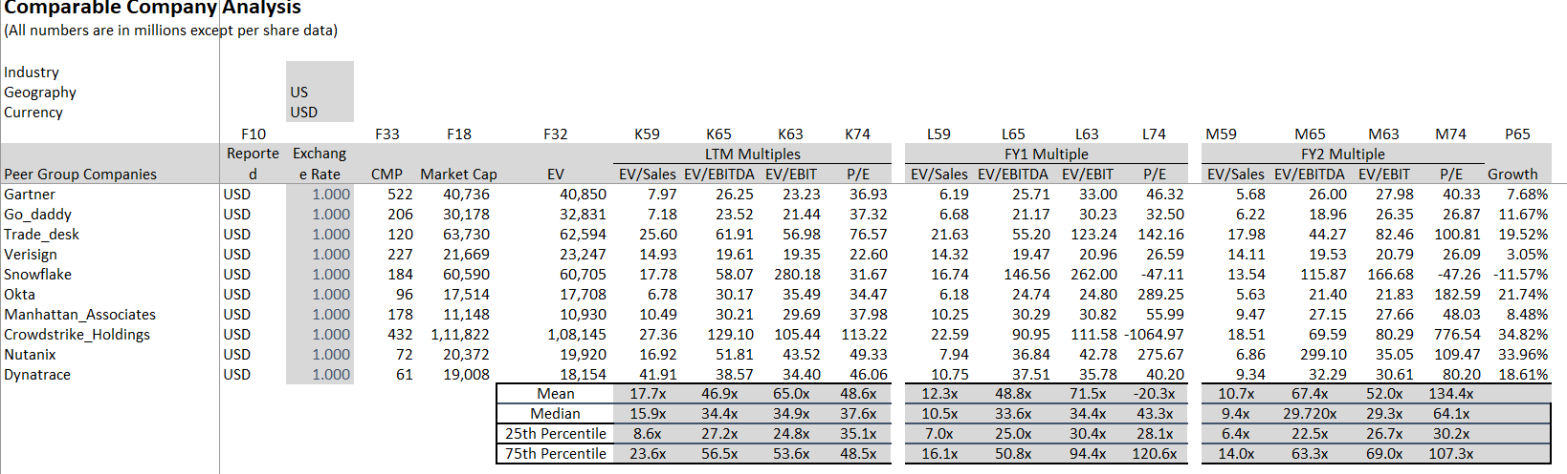

Exhibit 13- Football Field Analysis

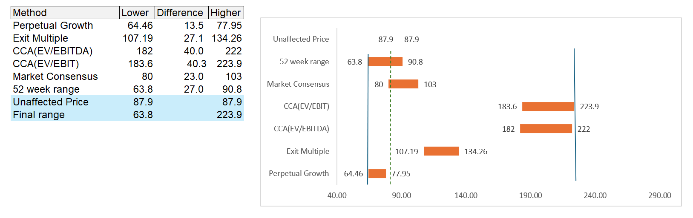

*This football field analysis presents a valuation range for the target company using various methods. The* ***perpetual growth*** *model yields the lowest range ($64.46 - $77.95), while the* ***CCA (EV/EBIT)*** *method produces the highest ($183.6 - $223.9). The* ***market consensus*** *and* ***52-week range*** *fall within the broader spectrum. The* ***unaffected price*** *is $87.9. The* ***final valuation range****, encompassing all methods, is $63.8 - $223.9, highlighting significant variability in potential valuations.*